Chapter 19, Problem 32.

Using Fig. 19.90, design a problem to help other students to better understand how to find the h and g parameters for a circuit in the s-domain.
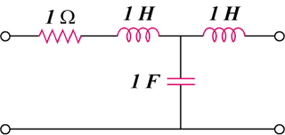
R
L₂
L₁
C

Figure 19.90
For Prob. 19.32.

